BUSA 3110 Name: Type your name here
Fall 2017
Prep 2 (2 points)

This assignment is due by 11:30pm on Tuesday, August 29. Submit this assignment to the D2L Assignment folder for Statistic for Business Section DA Fall 2017 [regardless of the section listed in Banner]. Assignments submitted after 9:00am on Wednesday, August 30 will receive a grade of 0. Assignments submitted between 11:30pm 8/29/17 and 9:00am 8/30/17 will receive a 10% penalty.

JMP Basic Navigation (Parts 1 & 2) https://www.jmp.com/en_us/events/ondemand/academic.html provides videos related to specific skills you will need to be successful in this course. Answer the following questions to respond to this assignment. Replace the highlighted words with your answers.

NOTE: I find viewing Basic Navigation (Part 2) first to be best.

Basic Navigation (Part 2): Getting data into JMP and saving output from JMP.

1. One of the most basic steps in analyzing data is getting the data into the software. Many times we obtain data in Excel (or csv) format. We will use a copy/paste approach where our Excel file will include columns with variable names in the first row and data below the variable names. JMP expects to see the variable names above row 1.
a) Given the following Excel data identify the columns and rows you would copy:
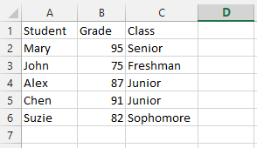
columns (enter column letters) rows (enter row numbers)

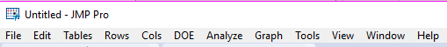
b) Based on the video description for pasting the data into a new JMP data table, which menu will you use? enter your response here

c) Which option under that menu will you select? place your answer here

d) Which of the following Data Tables should you see as a result? [the one on the left or right]
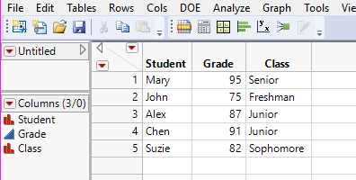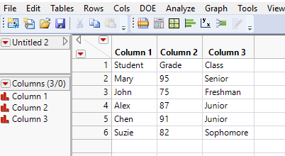

e) Justify your selection in part d by identifying at least two signals provided in the “incorrect” data table that would be indicate that something is wrong.

Signal 1: Place one signal here
Signal 2: Place a different signal here

2. Once you have obtained output from some analysis, you need to be able to save that output. We can consider saving output in two ways: 1) saving the actual JMP work so that we can come back and extend the analysis later, and 2) saving/integrating the results from analysis performed in JMP into a document such as Word.

a) To save our work in JMP (for submission of an assignment or for access in the future for additional work), we will use the process of writing JMP scripts to the data table and then saving the data table.

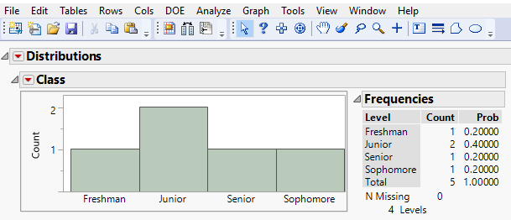
Using the output above as a place to reference, describe step-by-step the process that is used to save the JMP script that created this output to the data table. And remember that the last step needs to be “Save the Data Table.” [Note: When your steps are actually followed, the result should be a saved file with the extension .jmp.]
Type your answer here placing each step on a new line

b) To integrate output from JMP into a Word document, we could simply copy & paste the output…but this will result in tables showing editable text (i.e., the values in tables in the file could be easily altered). We will need to be able to integrate some of our output as images. Another reason for pasting output as an image is to maintain the clarity of the figure (when the size is changed). [Look carefully at the image below and the one in part a. One should look clearer than the other. The one in this part has been pasted as an image; and the one in part a was created by pasting a screen shot—both have been resized.]
Using the menus and icons below, describe the steps that would be used to copy the output above. Type your answer here.
Once the output that you want to paste into a Word document is copied, describe the steps that are used to paste the output as an image (be sure to specify if you are responding related to a Mac or Windows machine). Type your answer here.

Basic Navigation (Part 1): Overview of the Data Table, Basic Tasks, and Basic Output.

3. Overview of the Data Table. The following Data Table will be used to respond to the matching exercise in the a part of this question. There have been several changes to the data table from the one that was used in the earlier questions, so please refer to this image.
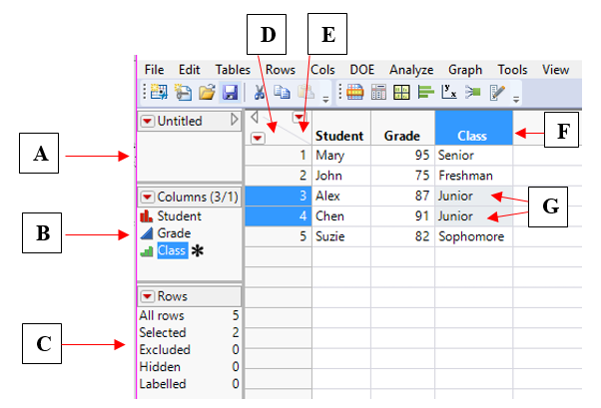
a) Provide the letter that best identifies the location described. No letter will be used more than once.

____ The place you click to deselect highlighted rows
____ Highlighted cells
____ The place where variables and their modeling type will be listed
____ The place that gives you information about the number of observation and additional information about their “status”
____ The variable names that identify the specific data associated with that variable
____ The place you click to deselect highlighted columns
____ The location where scripts (that were saved to the data table) will show up

b) For each of the following, describe what the icon is telling you about the data associated with that variable. Although JMP 13 includes a few (new) options, these are the ones that we will be using.
Put your response here
Put your response here
Put your response here

4. Basic Tasks
a) “Cleaning data” often involves making sure data entry is consistent. This includes making sure that the same spelling (with the same capitalization) is used of all entries that represent the same characteristic; in addition, there are times when combining two (or more) levels into one variable makes sense. The Recode option makes this work easy. Describe how to get to the Recode option in JMP.
Put your response here.

b) We have seen red triangles in many places. (Examples below) What do these red arrows signify? (i.e., What would you expect to see if you clicked on a red arrow [in general]?)
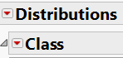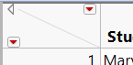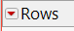

Put your response here

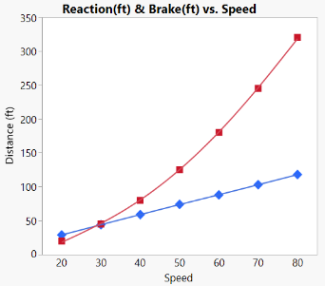
c) Use the letters associated with the output below to identify the figure that would be expected to come from each of the methods for summarizing and displaying data.

A B C
- summarizing data for one variable (numerically and graphically) with a single option
path: Analyze / Distribution Put your response here
- creating tables
path: Analyze / Tabulate Put your response here
- making graphs
path: Graph /Graph Builder Put your response here

Finally, and just so you can see the difference, compare the following analyses. Notice that the first output shows the Class variable as ordinal and shows an * to the right. Looking deeper, we would find that the * is indicating that we have specified the order that we want to see. The second output has the Class variable identified as Nominal. Since Nominal implies that ordering doesn’t matter, the categories are show alphabetically on the bar chart. No responses required for this part.
