BUSA 3110 Name:
Fall 2017
Prep 1

This assignment is due no later than 5:00pm on Tuesday, August 22. You should submit this assignment to the D2L Assignment folder for Statistic for Business Section DA Fall 2017 [regardless of the section listed in Banner]. You may need to click on the “waffle” icon and search for the section. Then you can pin it to your homepage for future use.

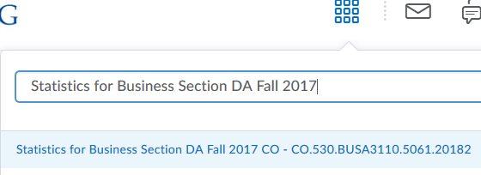

If you registered for one of my sections before August 15, you should be able to access the D2L site. If you cannot submit the assignment to the D2L section, e-mail the assignment to me as an attachment and include a note in the body of your email telling me that you do not have access to the D2L section so I can add you.

Prep 1: Read the course syllabus and respond to the following:

- What questions do you have related to items on the syllabus (or what parts do you not understand)?

Type your answer here:

- Based on the syllabus (and the university schedule), what is the date of your final?

Type your answer here:

Remember that the final is a required part of the course—so do not make travel arrangements that require you to miss the final.

Save your file using your last name and first initial as part of the file name. Upload this to D2L for Section DA by 5:00pm on Tuesday, August 22.

