French 1001, fall 2007, Exam III prep

I. Dictée : Write the following sentences in French as you hear them.

- Example: "C'est lundi le quatorze mars."

II. Répondre : Answer the following questions in French using complete sentences wherever possible (BTW: after test 1, it's always possible).

- Example: "Quelle est la date aujourd'hui?" Answer: "C'est lundi le quatorze mars."

III. A l'écoute: Here you will do 1 or 2 exercises directly from or similar to those found on the lab tapes. If you've been working on those, you're all set.

IV. Traduisez: Give the equivalent of the following in French..

- Example: French people (in general) like wine.

V. Structures: This will come from the grammar structures we have studied since the last test. Here are some possibilities - they might not all be on the test, but then again, they might.
A. Allal is describing his birthday meal: he’s eating all his favorite foods. Complete his description by supplying the appropriate partitive, definite, or indefinite articles.

- "Je vais prendre ____ légumes, mais je n’aime pas ________¹ pain," etc…

B. Marina has a very busy schedule, as you can see from her activities below. Choose an expression with faire for each of the situations described. (10 points)
modèle: Samedi, la maison est en désordre.
Elle fait le ménage.
- Samedi, elle prépare un dîner pour ses amis.
_______________________________________________________________________

- Nadine and Martine are visiting Joëlle at her apartment. Complete their discussion by supplying the most appropriate possessive adjectives (mon, ton, etc.).

- Joëlle: Voici ____ collection de jazz et de musique moderne, etc...

- Marc, Claude, and Françoise are discussing their plans. Complete their conversation by supplying the correct form of a verb (attendre, faire, perdre, rendre visite, répondre). This may be in the form of a verb chart instead.

- Your roommate is going out on her first real date in college, and she asks your advice about how to act. Answer her using the imperative of five verbs, such as parler, manger, danser, être, attendre, finir, etc. This may be in the form of a verb chart instead.
- ___________________________ !

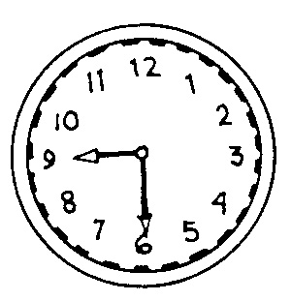
- Quelle heure est-il? Write out the time for each clock in either conversational or official (24 hour) format. Use complete sentences.

- Paroles: This means vocabulary, and it can come from any section - "Paroles," "Mots-clés," etc.
A: Describe the weather in your region in each of the seasons.
- En hiver, ______________________________________________

B: Write the food preferences of the following people at the meals or places indicated. Make the appropriate changes. (10 points)
modèle: Au restaurant / votre famille:
Au restaurant, ma famille préfère prendre du poulet, des frites et une salade.
1. Au petit-déjeuner / vous: _____________________________________________

VII. Lecture: You'll be given a short reading and answer some questions on its content. Don't worry, you won't have to understand every word to be able to do well.

VIII. Composition: From a context I will provide, you should be able to write a short composition.

NOTE: Usually only one of these last two sections appears on any one test.

